|  |  |  |  |  |
| --- | --- | --- | --- | --- |
|  |  |  | | |
|  |  |  |  | |
| Microsoft Viva:  Syntex Forms Processing Model |  | Syntex Forms Processing |  |  |
|  |  |  |  |
|  |  |  | Virtual Lab |
|  |  |  |  | |

## Module Overview

This lab creates a Syntex Forms Processing model that is used to extract Metadata from PDF quotes. This model can be run from either SPO or within Microsoft Teams. An optional component of the lab is to us the data that is pulled from the quotes with a Power Automate flow.

The video contained in this blog provides an overview of what you are going to build in this lab:

<http://myteams.blog/2021/05/12/syntex-forms-processing-power-automate/>

**Note:** the Power Automate flow is sightly difference in the lab due to changes released onto the platform.

# Lab Guide

### Estimated time to complete this lab

45 minutes

### Objectives

After completing this lab, you will be able to:

* Build a basic Form Processing model
* Link it to a Power Automate Flow to demonstrate how data extracted from the model can be used as part of a business process.

### Prerequisites

* Microsoft 365 Viva Tenant from: [Modern Workplace Digital Experiences (microsoft.com)](https://cdx.transform.microsoft.com/)
* Forms Processing Training files from: <https://www.linkedin.com/smart-links/AQFUNygTX2N5gw>
* Forms Processing Testing Files from: <https://www.linkedin.com/smart-links/AQH-1dwVkxXK2Q>

**Note:** Be sure to download the Training and Testing files onto your laptop, you will need these later.

1) Create a 90-day Quick Tenant located in North America.

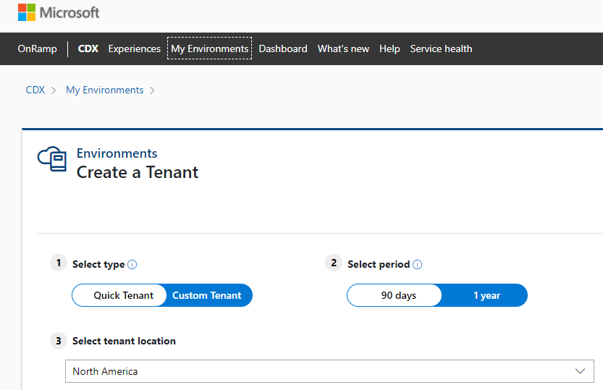

2) Viva Tenants can be found at the bottom of tenant list.

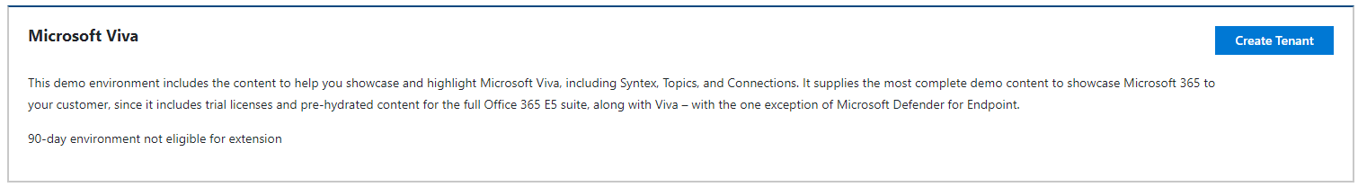

3) When the lab has been created you should see a screen similar to the one shown below:

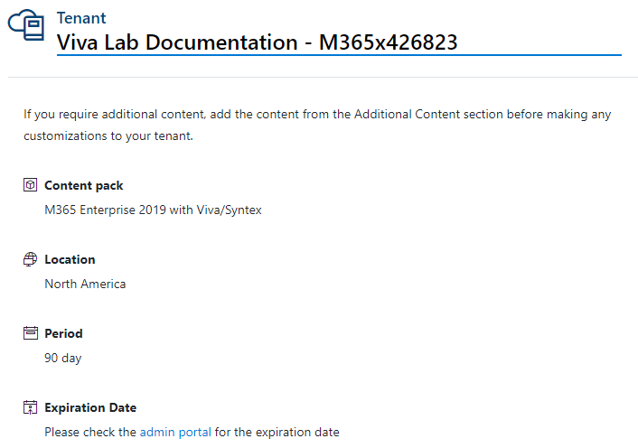

### Model Creation

1) Logon on to your Viva tenant as Megan Bowen (meganb) - <https://portal.office.com>

For example, use - [meganb@M365xXXXXXX.onmicrosoft.com](mailto:meganb@M365xXXXXXX.onmicrosoft.com) (replace the XXXXXX with your tenant number), use the password that was provided in the CDX tenant window. All users have the same password.

Don’t forget to use a private/incognito browser session.

2) From the Office 365 Home Page open SharePoint.

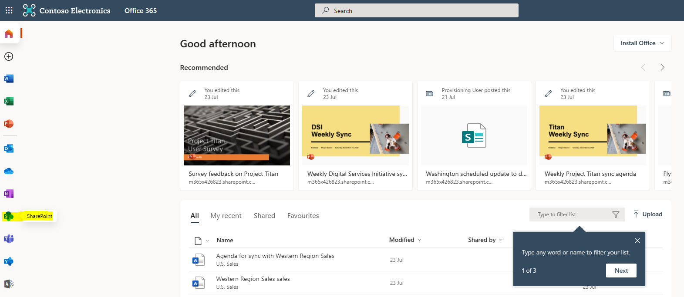

3) Navigate to US Sales

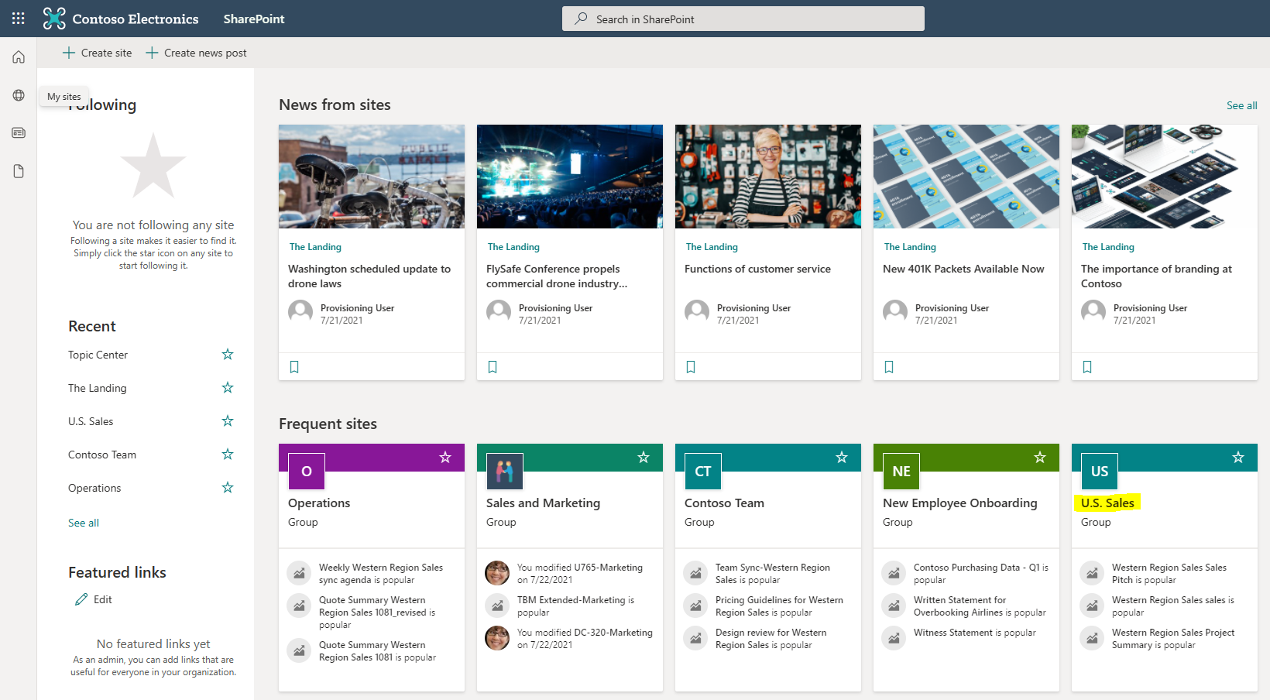

4) Then go to Documents and open the General Folder. Create a new folder called Quotes.

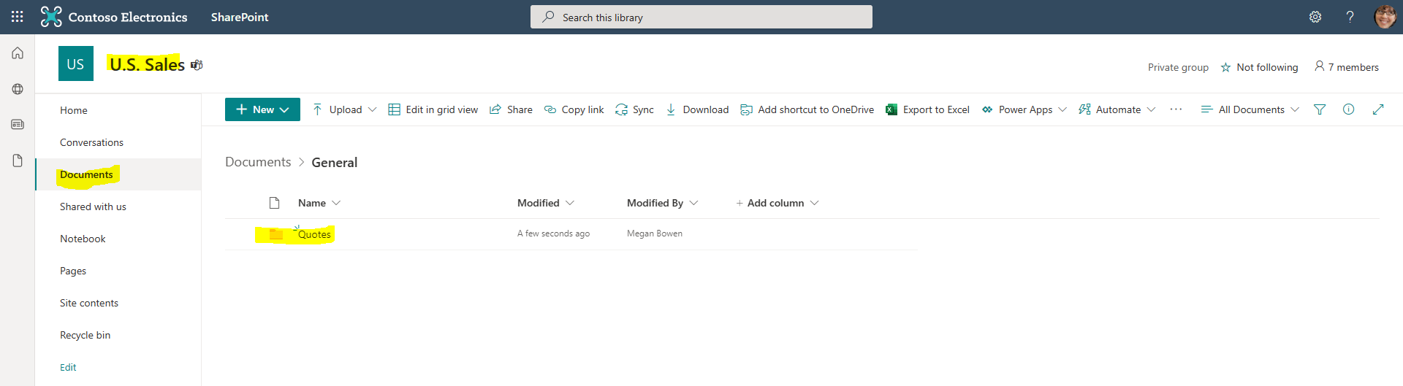

5) From the Automate drop down menu select “Create a model to process forms”.

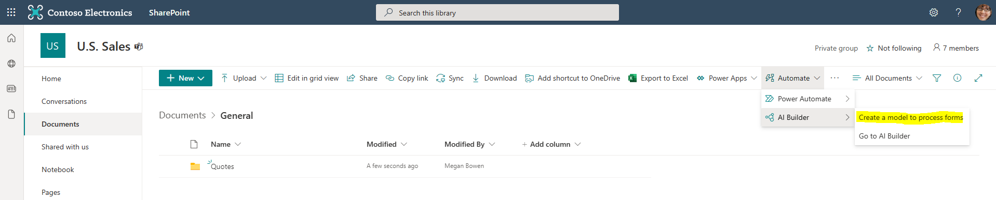

6) Give the model a name and press the Create button. Leave all the other configuration options in their default states.

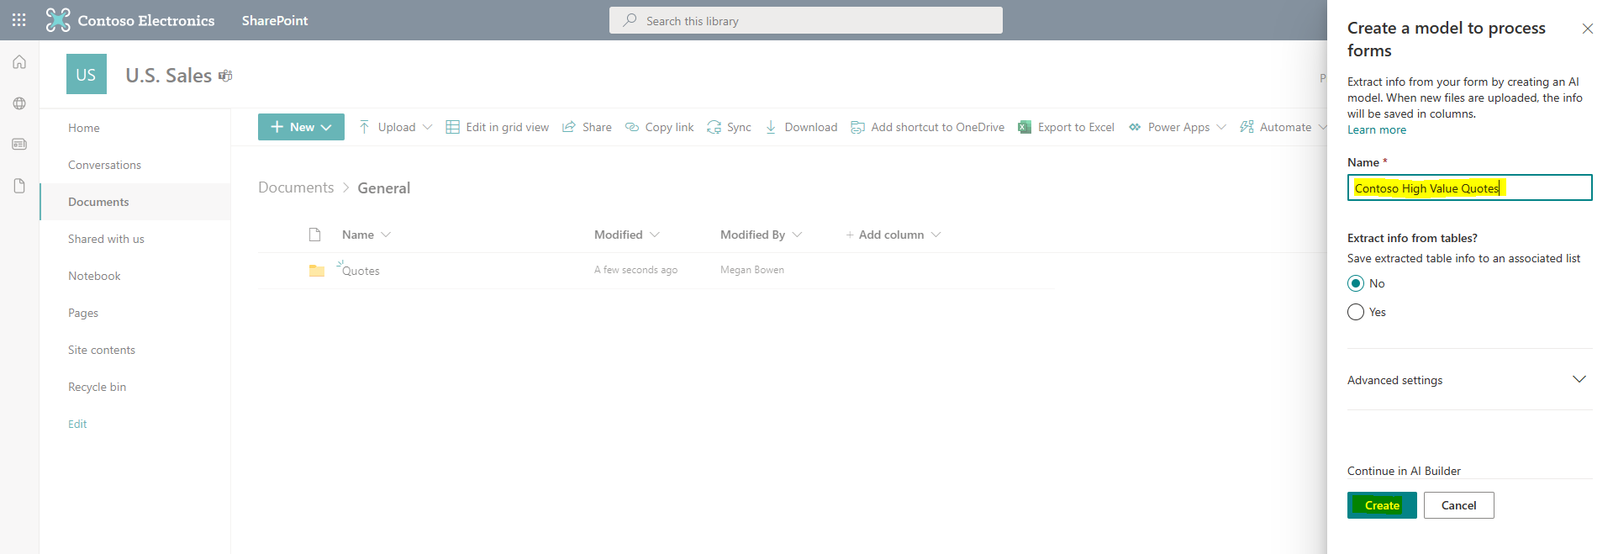

7) You are now taken to AI Builder. It will likely take a few minutes to get things ready. When AI Builder is ready, we will add Fields that map to the data we want to extract. The first Field we want to pull out is the “Customer Name”. Press the Add button and enter “Customer Name” and select the Done button.

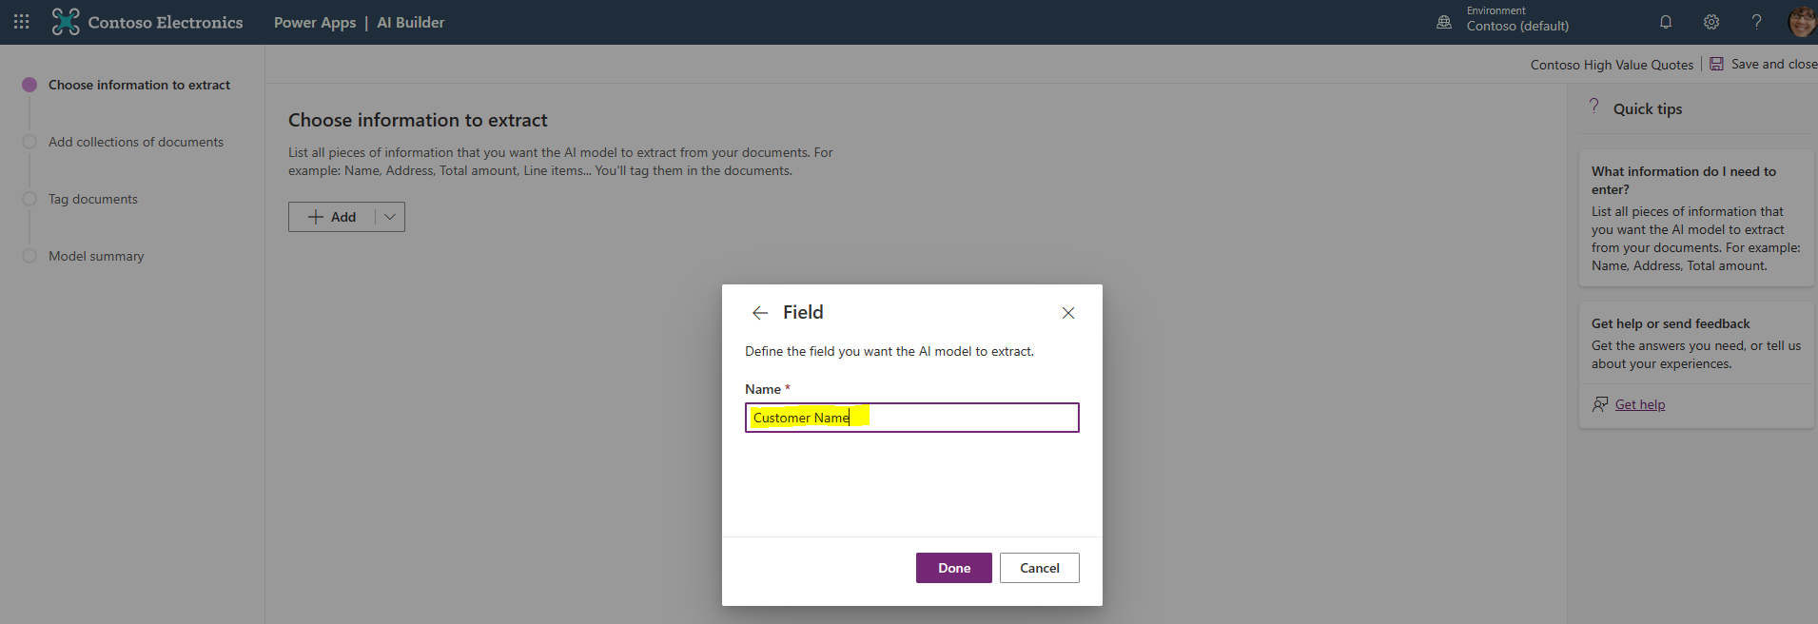

8) Next, add the following additional Fields: “Customer ID”, “Invoice”, “Salesperson”, “Total”, “Due Date”. The Fields you should have defined are shown below. When you have finished adding them, select the Next button.

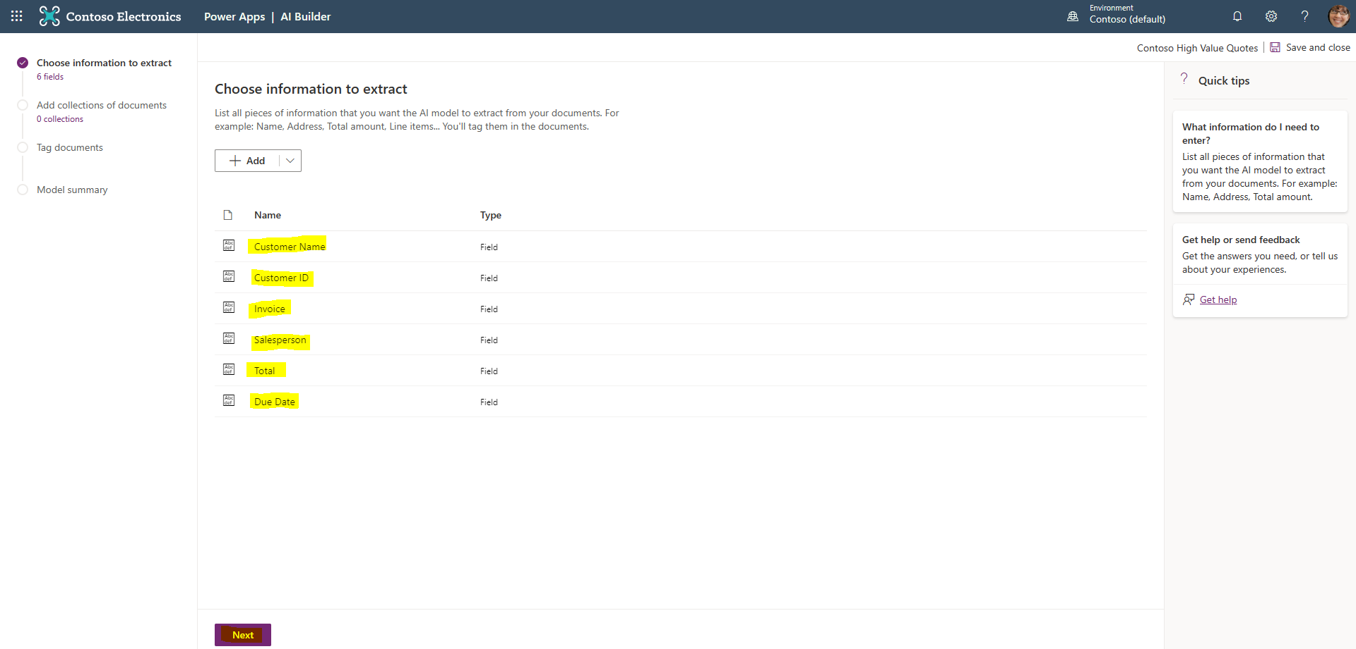

9) We are now going to add a New Collection. As all our forms have the same structure, we only need a single collection in our model. If AI Builder is new to you, be sure to read the Quick tips on the right-hand side of the screen. When we click on Collection 1, we are provided the option to add our training documents. Navigate to the location when you downloaded the Forms Processing Training files (from the prerequisites section) and add them to the Collection.

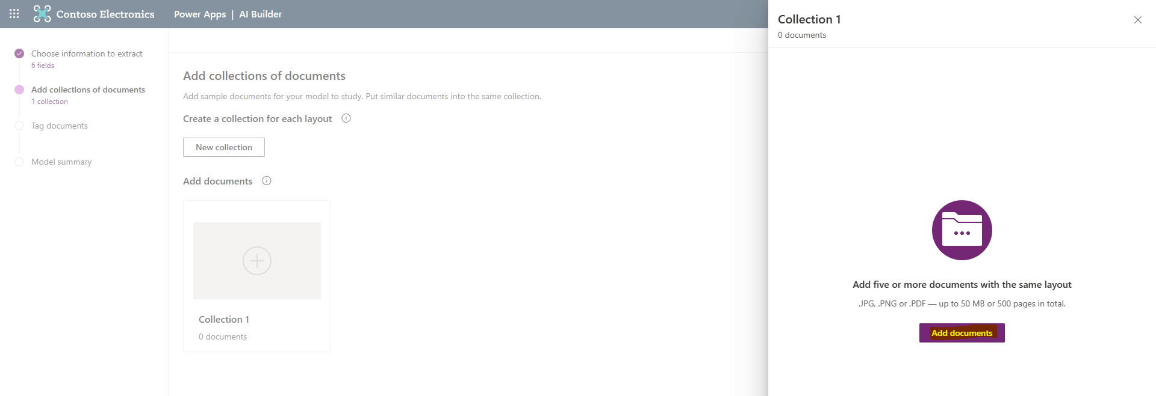

10) After you have added the five Training documents, press the Analyze button. You will receive a pop up telling you the analysis may take a few minutes.

When completed, you will a screen layout that’s like the one shown below. Be sure to click through the View documents help screen, as these provide guidance on what we will be doing next.

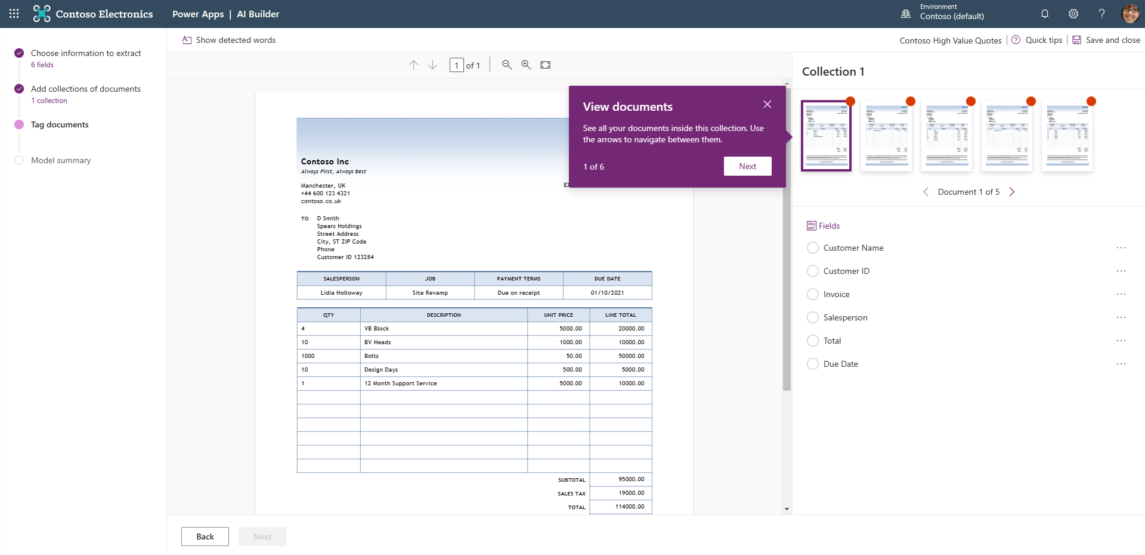

11) As per the instructions in the View Document help boxes, we are now going to highlight parts of our Quote form and map them to the Fields we defined previously. In the example below the Customer Name is associated with the second line of the customer details, which is “Spears Holdings”. To do the mapping we use our mouse to high the name on the form and click the associated Field name in the configuration box that appears.

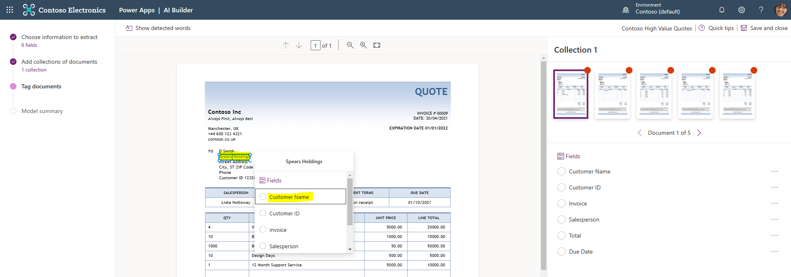

12) The next Field we’ll map is the Customer ID. An example is shown below. The subsequent screen shots show the rest of the mapped Fields.

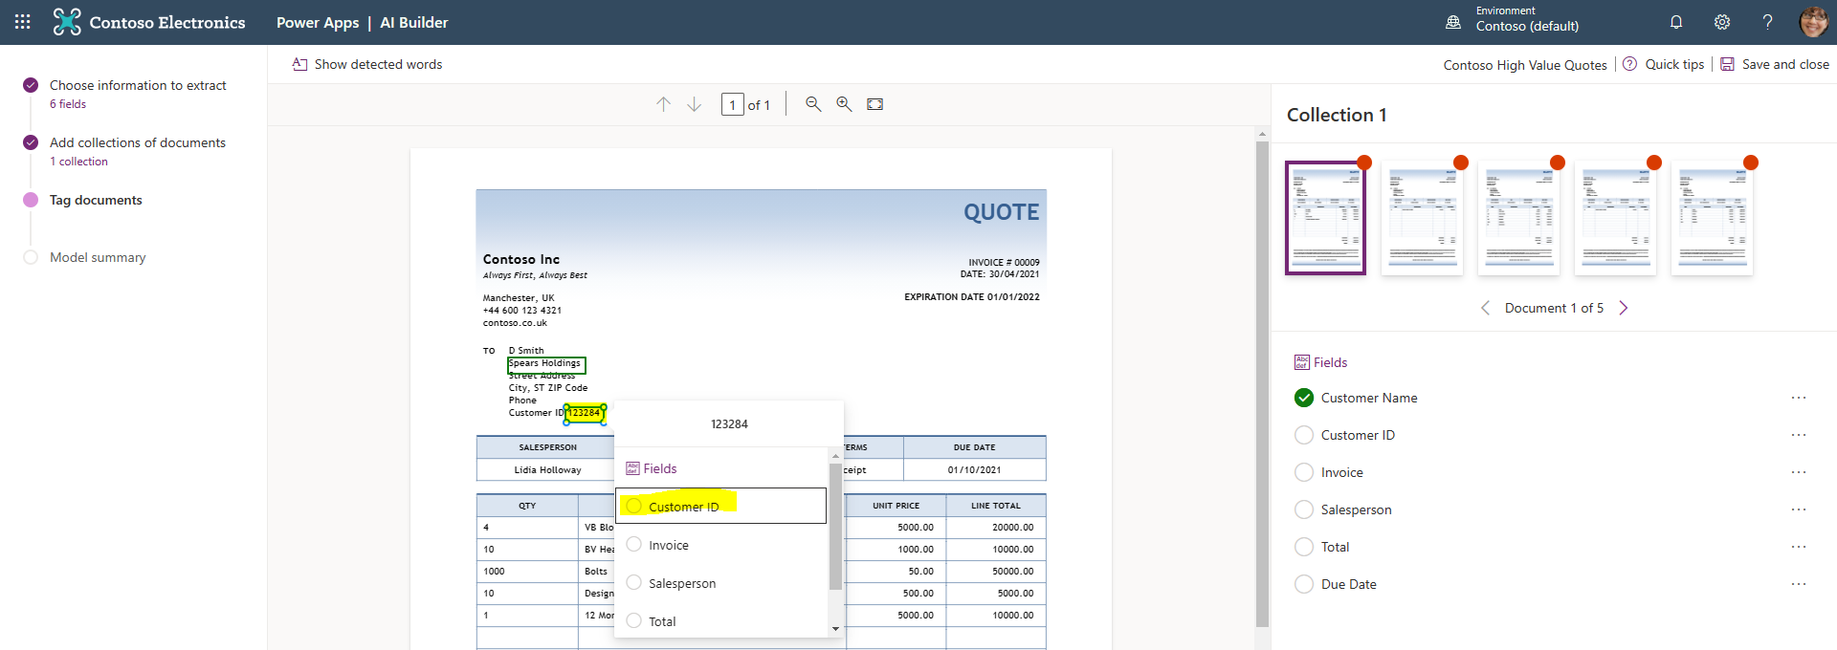

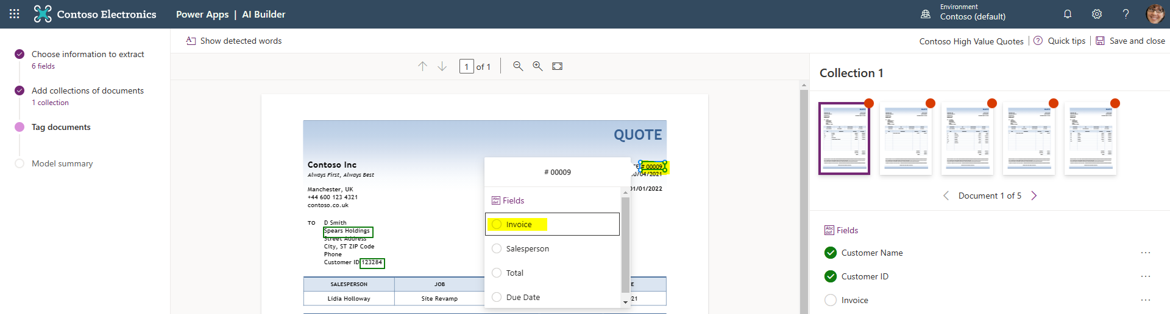

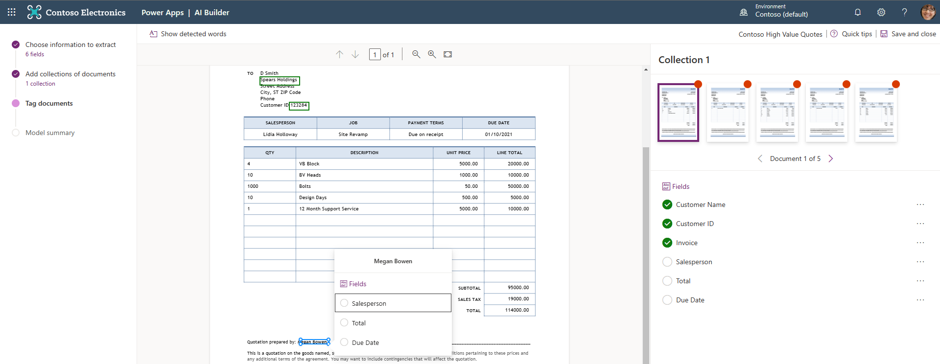

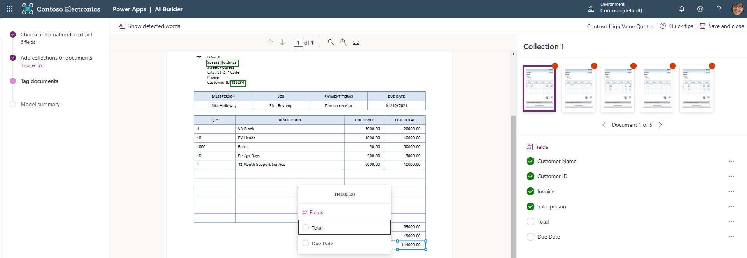

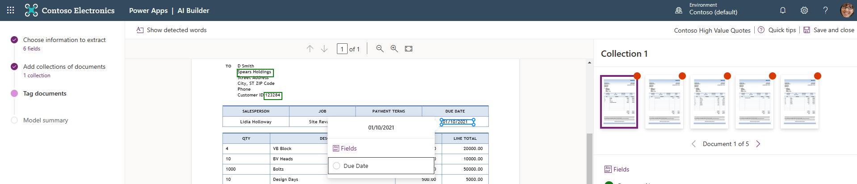

13) After you have completer the Tagging process for the first document. Select the second document in Collection 1. You should see that some of the mapping/tagging has automatically occurred. You now just need to re-tag the Fields that haven’t been mapped by the system. In the example below it’s the Customer ID and the Invoice number.

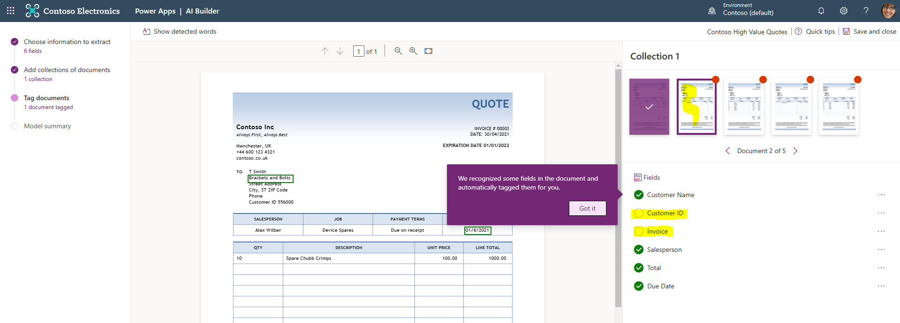

14) Tag the Customer ID in the second Training doc.

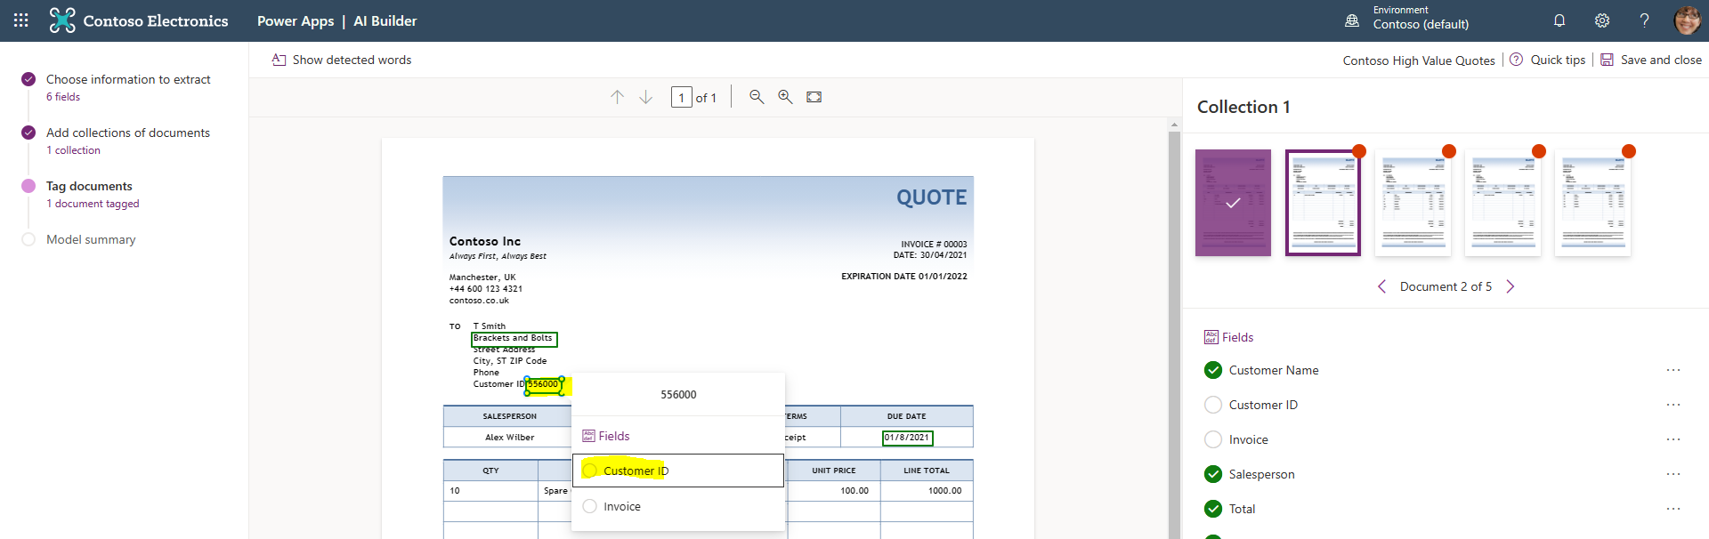

15) Then tag the Invoice number.

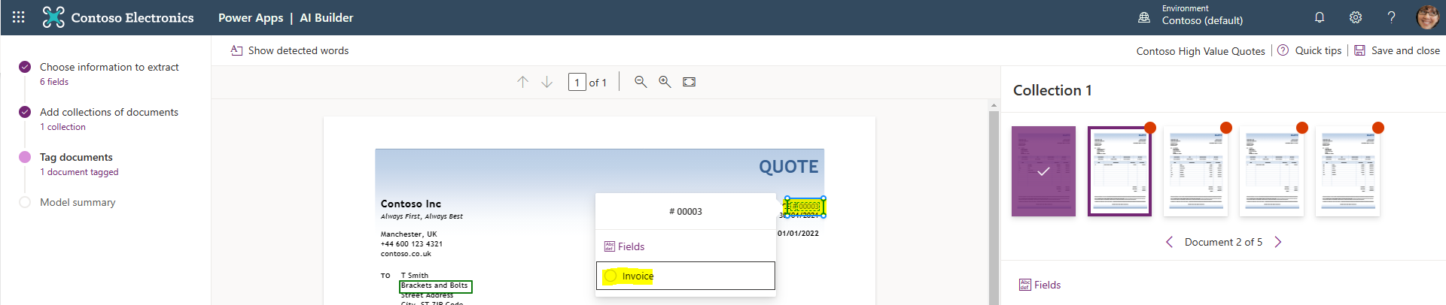

16) Once all the Fields are mapped in Document 2. Select Document 3 and continue to tag any of the fields that aren’t automatically mapped.

17) Continue to tag the remaining unmapped Fields for your remaining Training documents. When you have completed this task select the Next button and then Train the model. You will see a popup telling you that the model is training. It will take a few minutes to complete this step of the process.

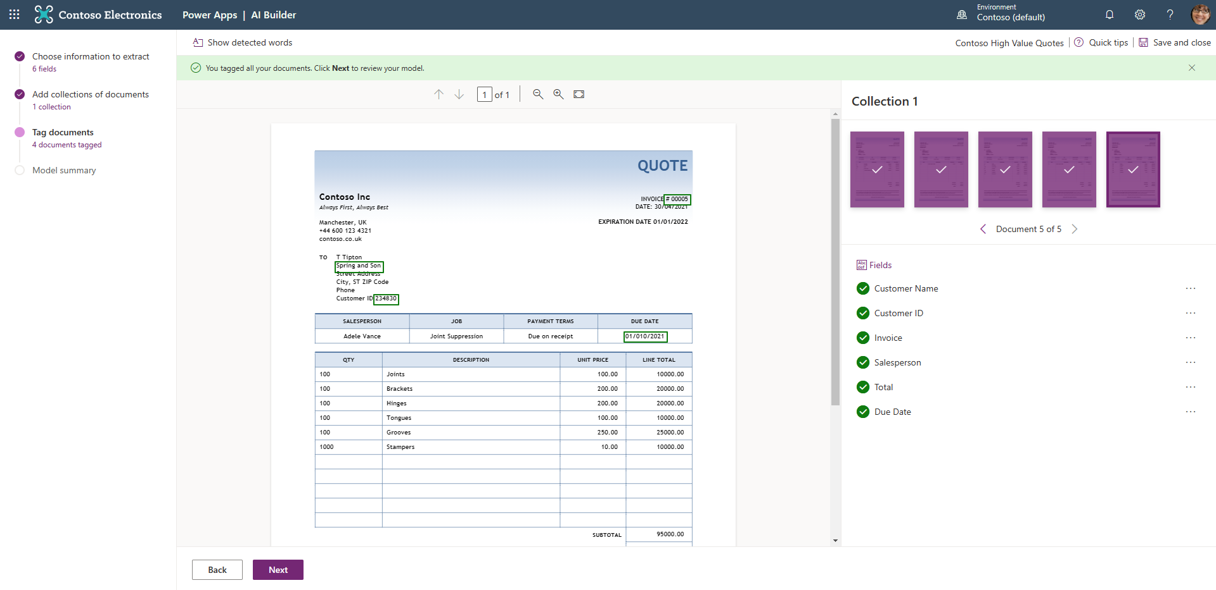

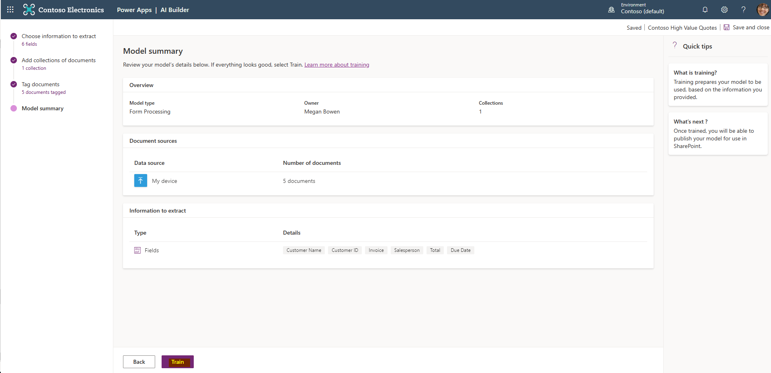

18) Once the training is complete, you can Publish the model.

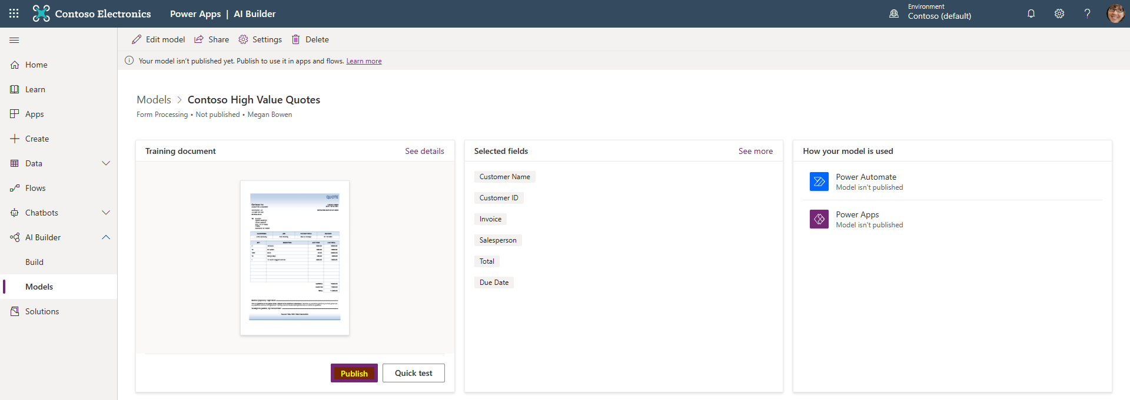

19) The next step is to press the Use model button and link the Form Processing model to SharePoint. After you press the Continue button you will see the SharePoint and Microsoft Dataverse sign-in icons. You may need to click the link of the Dataverse to sign in. Once you see two green ticks next to the Apps press the Create Flow button. Then go to SharePoint.

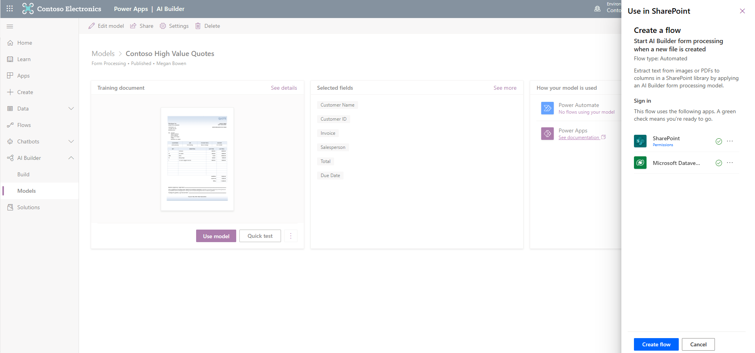

20) Navigate to the Quotes folder you created in US Sales > General and use the Upload button to add QUOTE_00728 to the library.

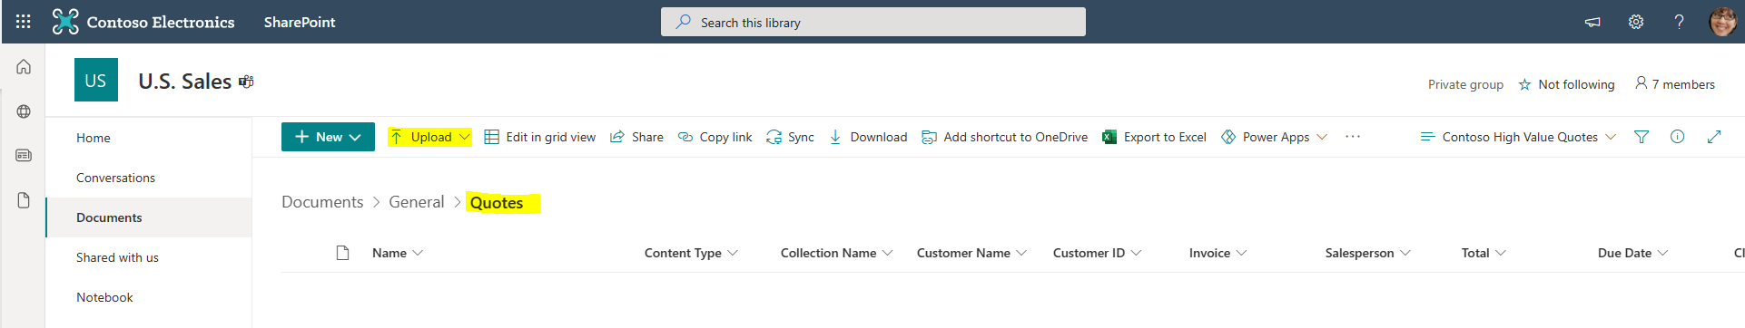

21) You should see a message saying “We are analyzing your file”

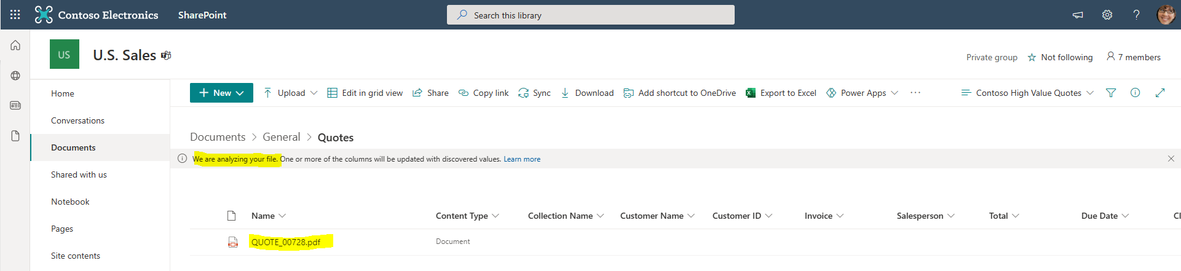

22) Then after a few minutes the metadata will be extracted.

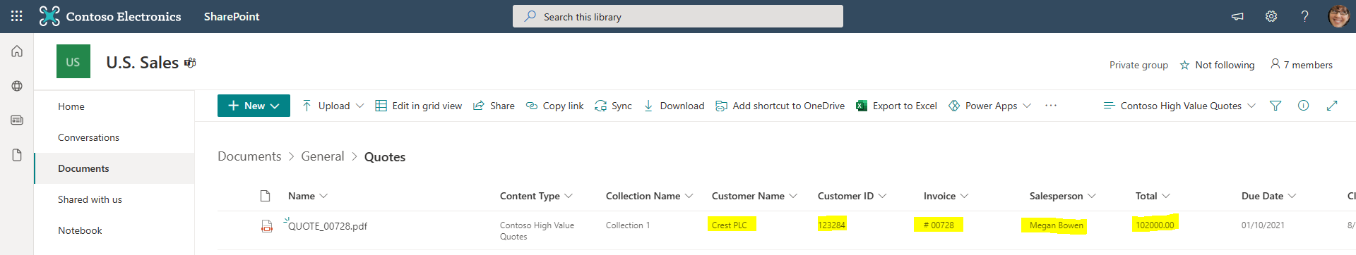

23) As you have possibly realised, US Sales is a Microsoft Team. Open Teams and look in the Quotes folder in the US Sales Team. As you can see the metadata is displayed. What happens if you upload QUOTE_00832.pdf through the Microsoft Teams interface?

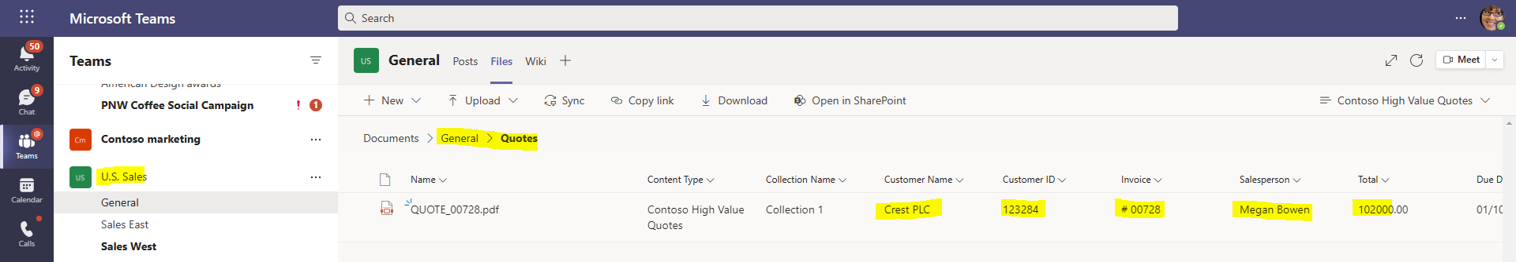

## Optional: Using the extracted Metadata

This part of the lab runs through the creation of a simple Power Automate Flow that uses the extracted metadata to identify high value quotes. If a quote is posted that is equal to or greater than 100,000, then a message is posted in the Microsoft Teams US Sales General channel. The idea behind this is to ask the US Team members to review the quote to ensure it is accurate and does contain any errors.

1) Navigate to Megan’s Power Automate portal and create a blank Automated cloud flow.

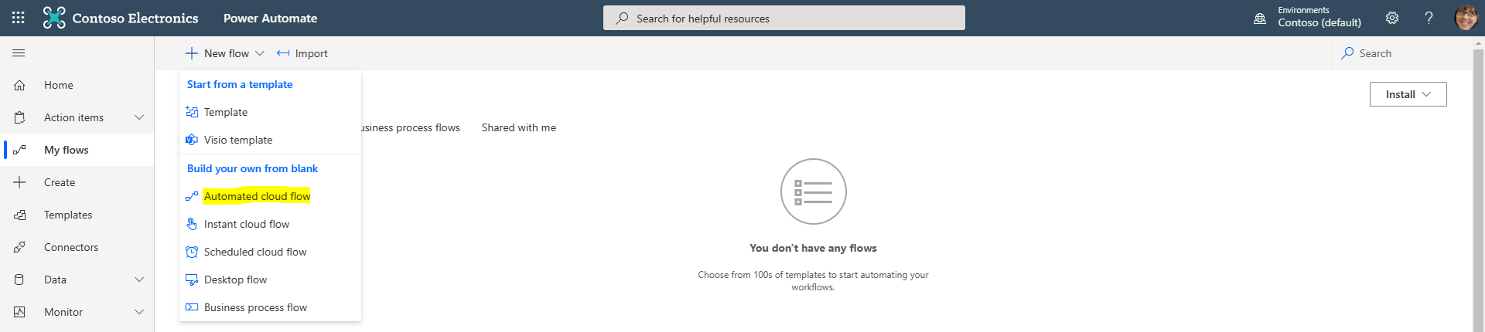

2) Give the Power Automate Flow a name and select the trigger “When a file is created in a folder”.

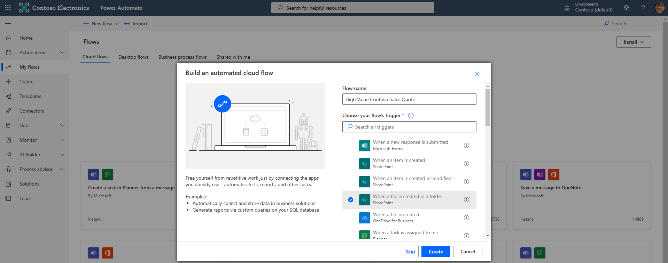

1) Select US Sales as the Site Address and make sure the Folder Id points to the Quotes folder. Then add a New step.

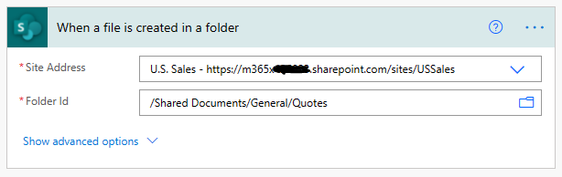

2) Now add the “Get file metadata” operation and select x-ms-file-id as the File Identifier.

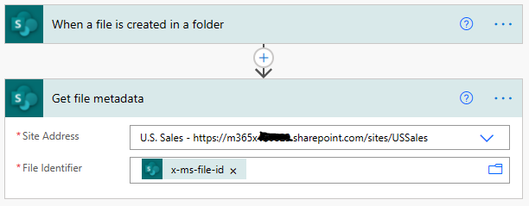

3) Add a New step and configure the “Get file properties” as shown below. This is the operation that will make the extracted Syntex metadata available for use later in the Power Automate Flow.

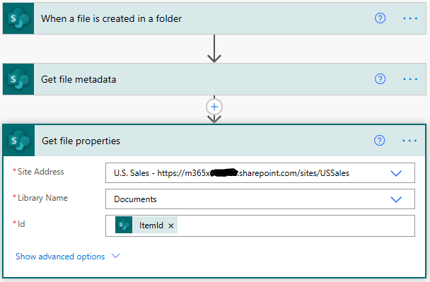

4) We are now going to add a “Condition” to check if the Sales Quote Total is equal to or greater than 100,000. To do this we use the Integer Expression “int()”, then select Dynamic content and choose the “Total” SharePoint parameter.

When configured correctly, if you hover over the mauve fx int(…) box you should see the following expression displayed.

**int(outputs('Get_file_properties')?['body/Total'])**

The reason we use this function is to change the 100,000 value in the Quote to an integer, as this is a requirement of the Condition operation.

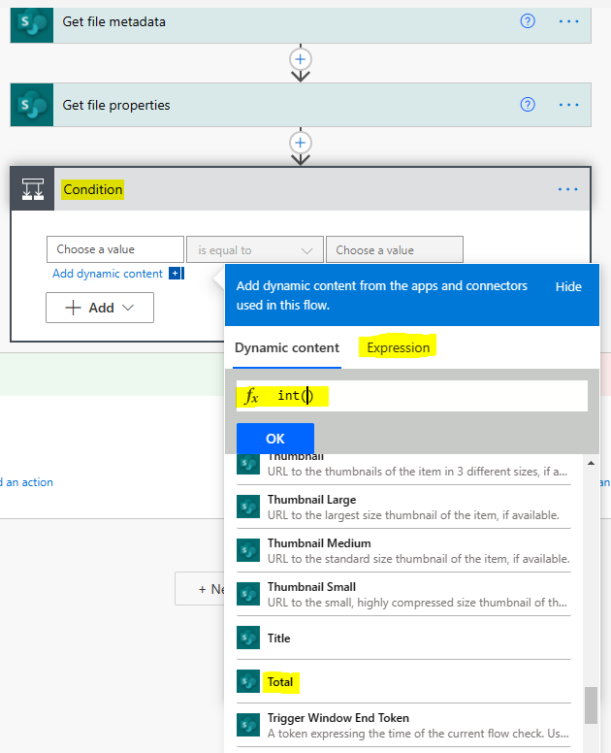

5) The “Condition” operation should look like the below screenshot.

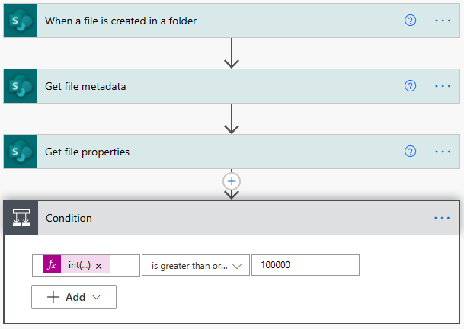

6) In the If Yes half of the Condition simply create a Teams post that will ask the wider team to sanity check high value quotes when they are added to the Quotes file store. An example for you to copy is provided below:

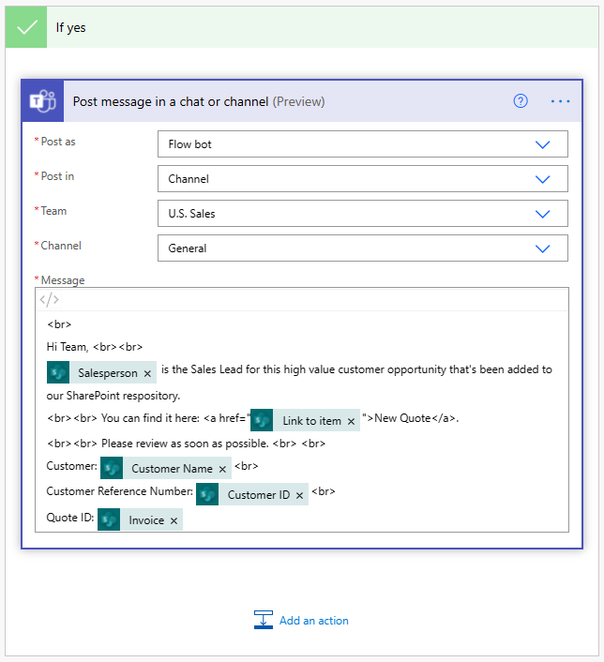

7) Now test the end-to-end demo by uploading the QUOTE_01001.pdf document into the US Sales Team’s Quote file store.

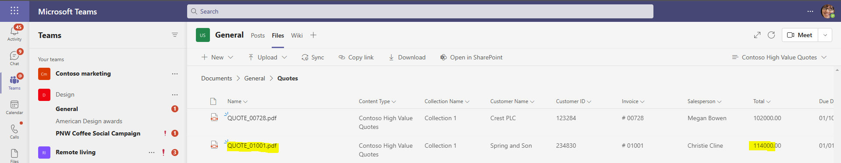

8) When the flow has run, you should see a message posted into the Teams channel.

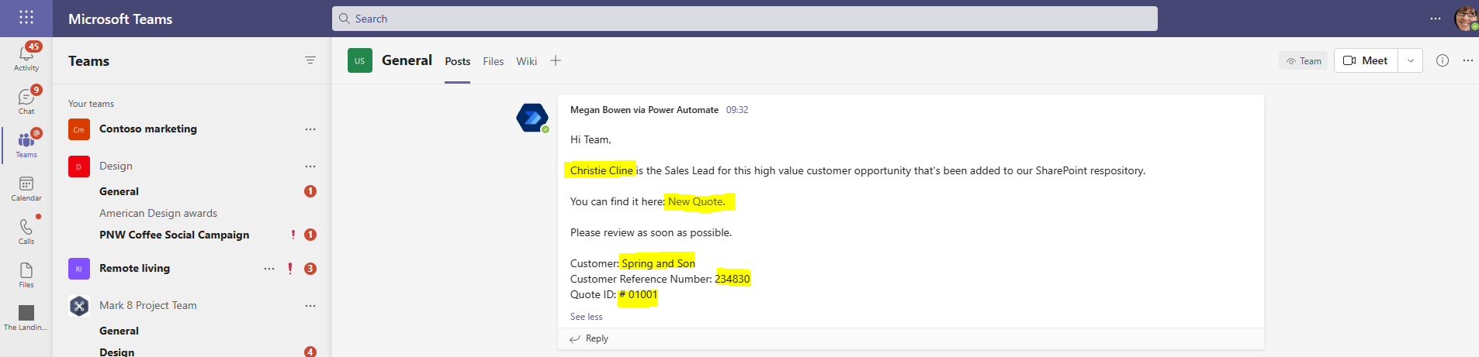

Congratulations – you have completed the lab and built a working forms processing model!